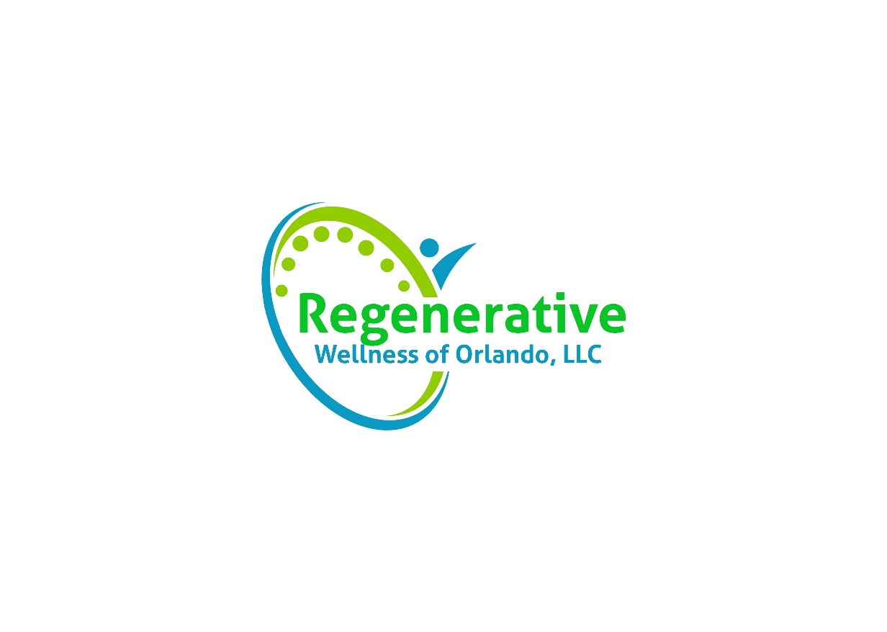

Regenerative Wellness of Orlando, LLC is not a provider of any one insurance. It is important that there be a clear understanding of this, and as a result, a clear understanding of what our procedures are regarding insurance.

You will always be informed of what procedures will be performed before they occur, and you will be informed of the fees associated with those procedures. You are responsible for payment on the date of services.

We do not process insurance forms at this office, nor do we have interactions with insurance companies. Each visit or periodically, we can provide you with an itemized receipt (a “Superbill”) with all of the necessary codes and information for you to submit to your insurance company. Your insurance company may reimburse you for a portion of your office visit if you have out-of-network benefits. You assume sole responsibility for obtaining the receipt from us, interacting with your insurance company, and pursuing reimbursement. We do not guarantee reimbursement, although some of our patients do have success.

Ultimately your health choices are yours alone, not any insurance company, their representatives, or a policy manual.

By signing this form, you acknowledge that you are responsible for payment of services rendered and there is no guarantee that your insurance company will reimburse you for any procedures and treatment.

_________________________________________ __________________
Patient Name Date

_________________________________________
Patient Signature

